CS 255 System Design Document Template

This template lays out all the different sections that you need to complete for Project Two. Each section has guidance to prompt your thinking. You will need to continually reference the interview transcript as you work to make sure that you are addressing your client’s needs. There is no required length for the final document. Instead the goal is to complete each section based on what your client’s needs are. Remove this note when you are finished, and replace all bracketed text with the relevant information.

UML Diagrams

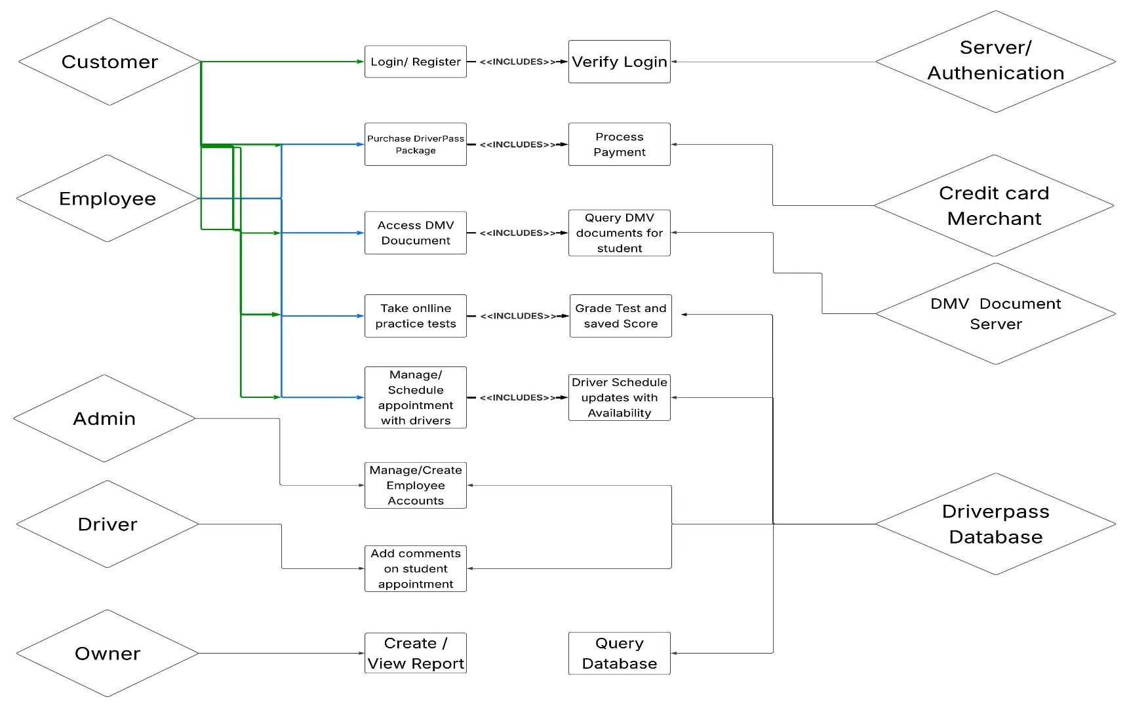
UML Use Case Diagram

UML Activity Diagrams
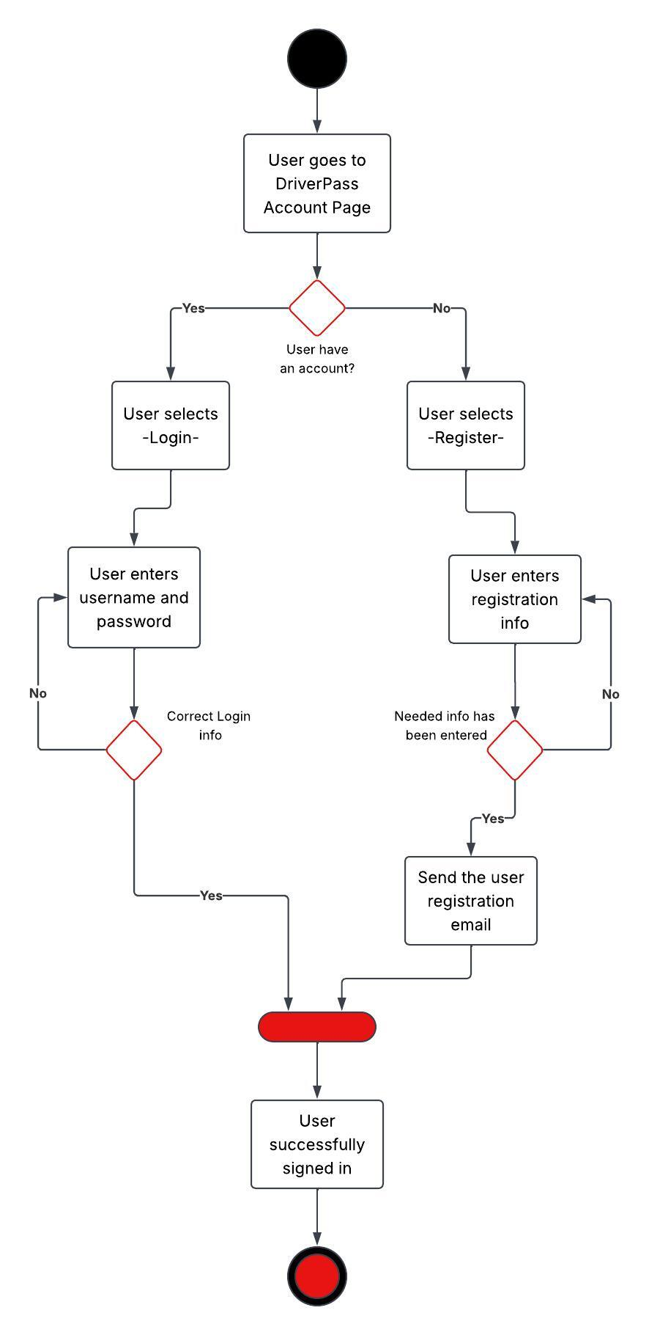
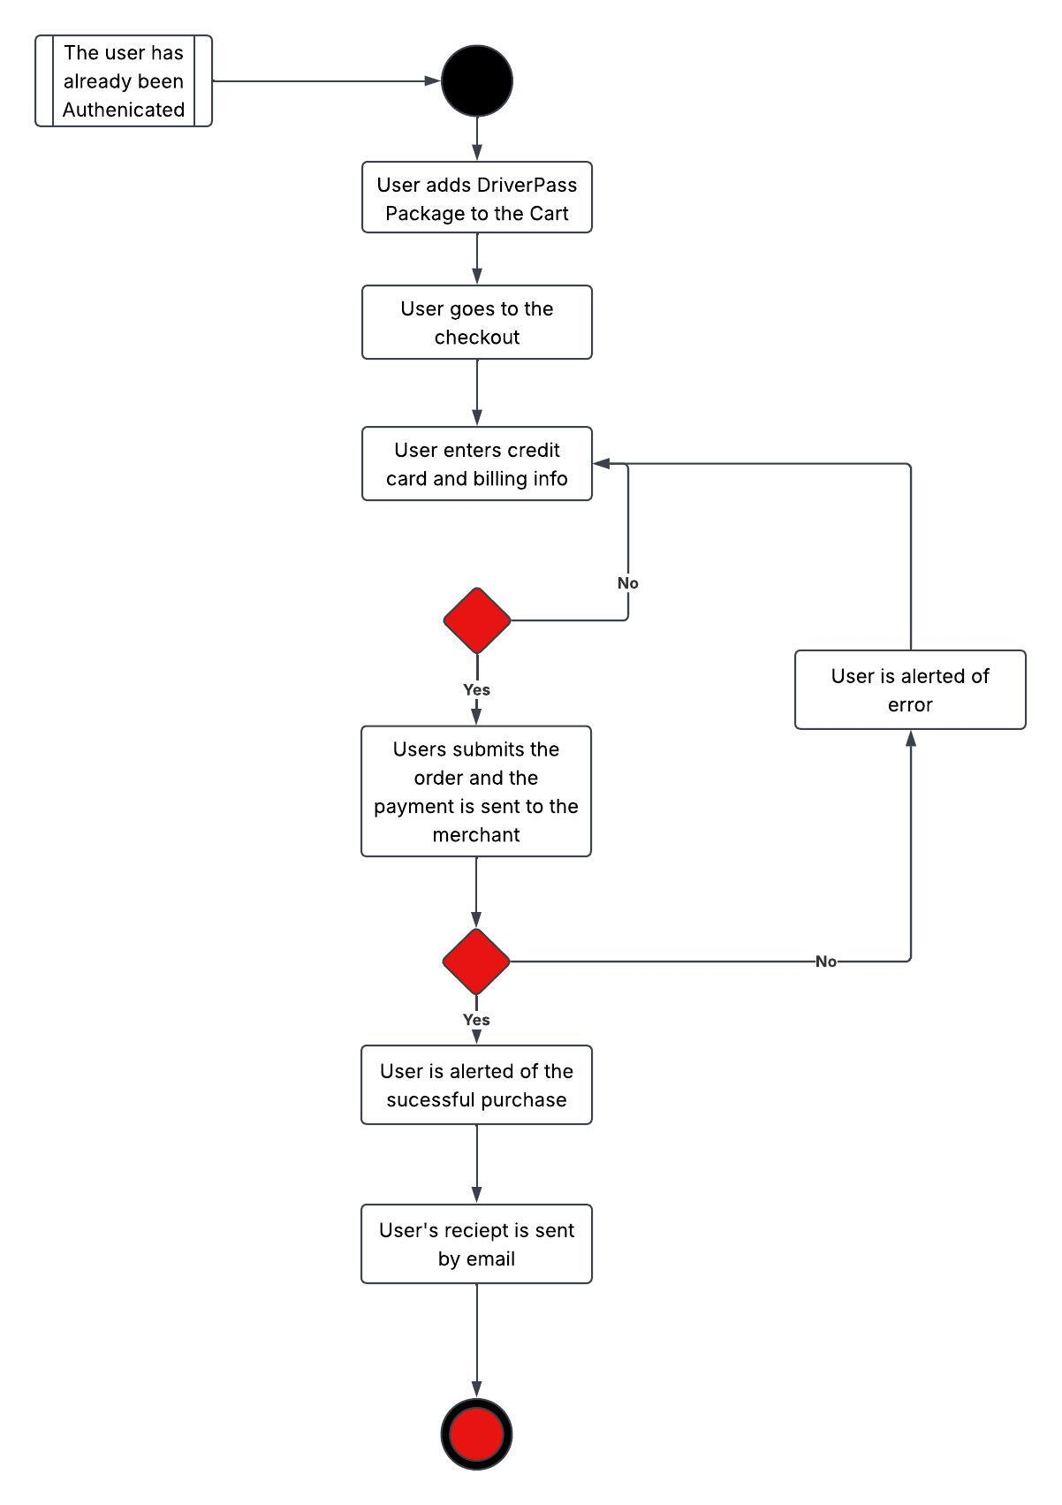

UML Sequence Diagram
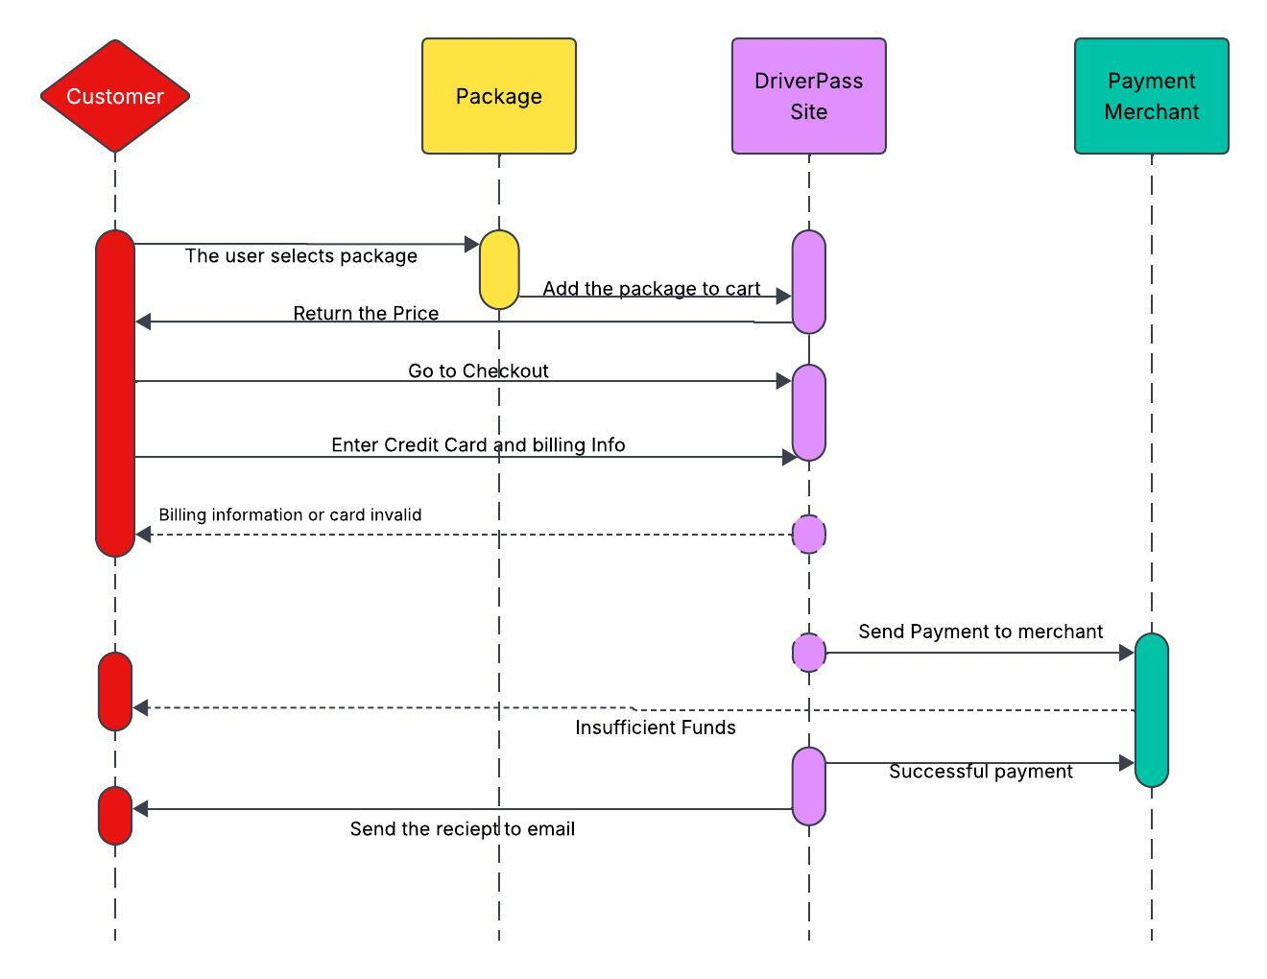

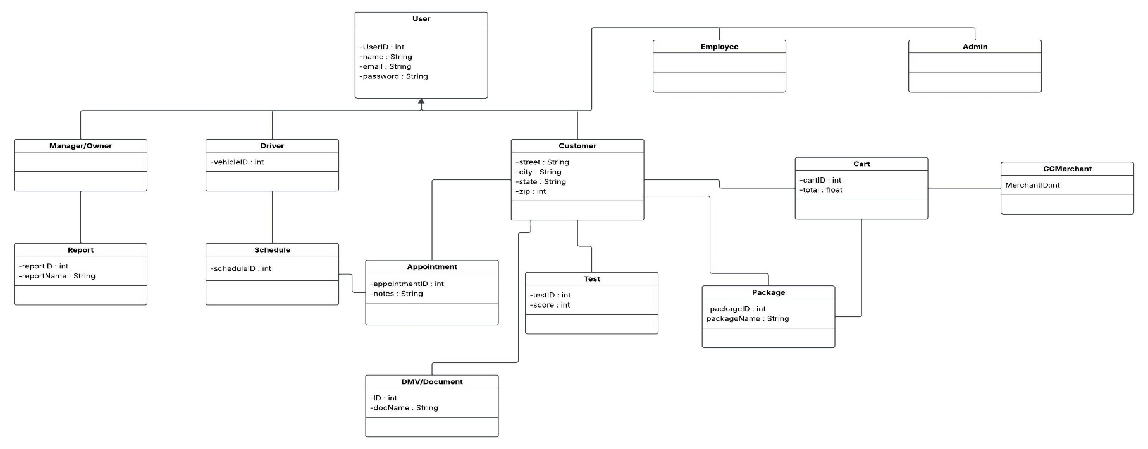
UML Class Diagram

Technical Requirements
To set up a solid website, you'll need a dedicated server with a reliable internet connection and storage for your database and website data. Users will access the site from computers or mobile devices, so ensuring security with a firewall is essential. For software, go with a stable version of Windows Server and use SQL Server for your database, along with backup software to keep everything safe. A web server like Apache is also necessary, plus some security software to protect against malware. Ideally, your website should be accessible in America, with the server securely located in a data center, preferably in a central location to ensure quick access for users.

